WEEKLY REPORT DE BENEDETTI MATTEO
WEEK 12: 25/11/2019 – 29/11/2019

FINAL REFINEMENT OF THE BODY-CAMERA TRANSFORM:
As mentioned in the report of the previous week, the body-cam transform has been further refined (using a 0.1 degree variation on all angles and also varying the position on x,y,z).
This resulted in a small improvement of 1mm, after 3m traverse, in xyz error norm, and 0.1 degree in heading (roll and pitch are not influenced by this since they come from the IMU).

VELOCITY TESTS:
The tests at different velocities have been re-run using the SpartanVO with IMU with the new body-cam transform and recalibrated Vicon.
The result is close to what was previously obtained: the slope of the error curve over distance is very similar across all velocities and does not increase directly with the speed.
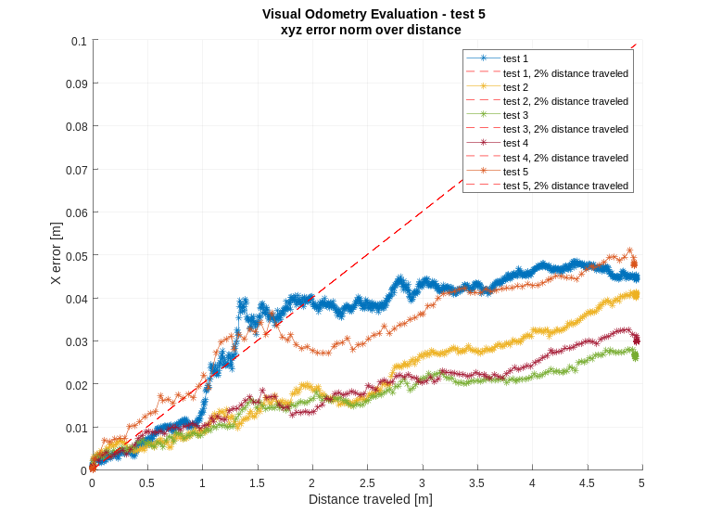
Velocities:
test1: 0.01 m/s
test2: 0.03 m/s
test3: 0.05 m/s
test4: 0.07 m/s
test5: 0.09 m/s
Slope of the fitted line:
test1: 0.0090
test2: 0.0076
test3: 0.0047
test4: 0.0055
test5: 0.0088

EXPOSURE TIME TEST:
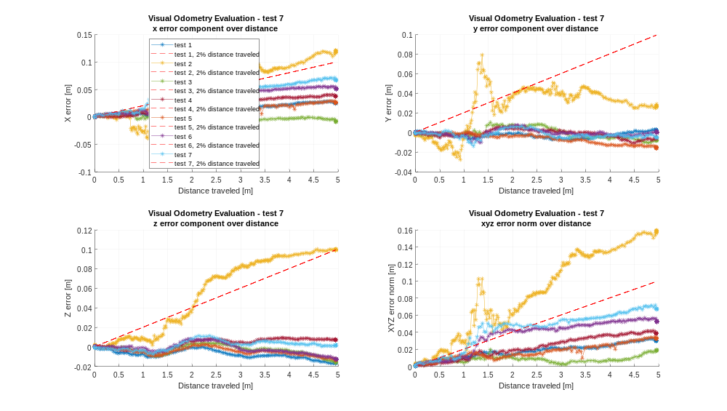
The next parameter that has been investigated is the exposure time.
Different exposure times have been tested against a single constant velocity of 0.07 m/s (that is the velocity that the Sample Fetch Rover is going to travel at, and one of the main differences between the SFR and the other mars rovers).
test1 = auto-exposure
test2: exposure time = 200 ms
test3: exposure time = 300 ms
test4: exposure time = 400 ms
test5: exposure time = 500 ms
test6: exposure time = 600 ms
test7: exposure time = 700 ms
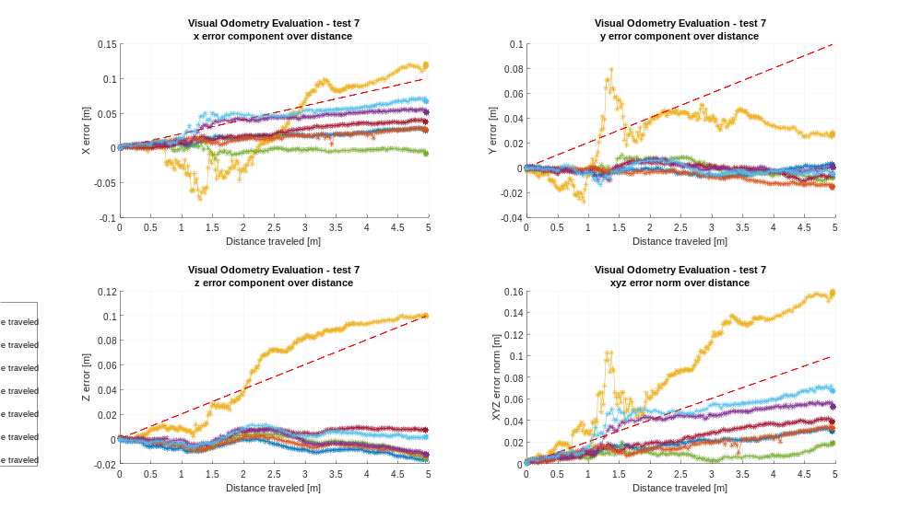
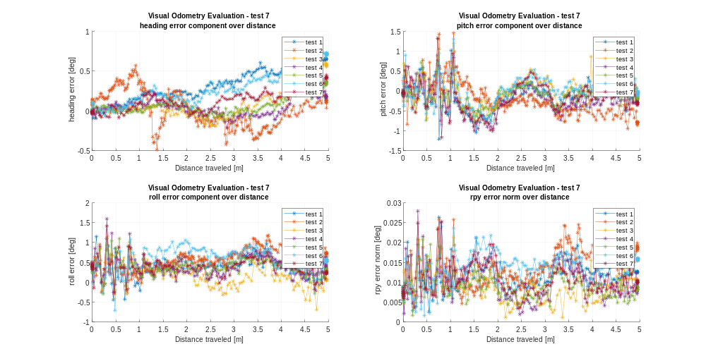
Test3 (that is exposure time=300ms) seems better than auto-exposure (that is around 530ms).
This means the lowering the exposure time can be beneficial at high speeds because it helps reducing the motion blur (test3) but if lowered too much it starts to be counterproductive because it also strongly reduces the brightness and contrast of the image (test2), while a high exposure time (test4-5-6-7) leads to an even higher motion blur that will negatively affect the VO performances.
To measure the motion blur, rather than the visual inspection of the frames while the robot moves, a simple metric has been used: the image is filtered with a Laplacian kernel [0 1 0;1 -4 1; 0 1 0] and then the maximum is taken.

Changing the exposure time strongly affects 2 elements: the brightness of the image and the motion blur which is, obviously, heavily depends on the rover’s speed. Therefore it has been decided to perform more tests to investigate also lower speeds and lower ambient light.
A lower light scene is of particular interest for the SFR scenario, that is supposed to be driven for most part of the Sol (Mars day), meaning also during part of the Martian dawn and sunset.

REDUCING THE EXPOSURE TIME AT LOW SPEED:
For a better comparison, the test1 and test2 show the beneficial effect of reducing the exposure time at high speeds, while test3 and test4 show that, for lower speeds, there is no significant improvement.
test1: 0.07m/s with auto-exposure
test2 0.07m/s with exposure-time=300ms
test3: 0.02m/s with auto-exposure
test4 0.02m/s with exposure-time=300ms
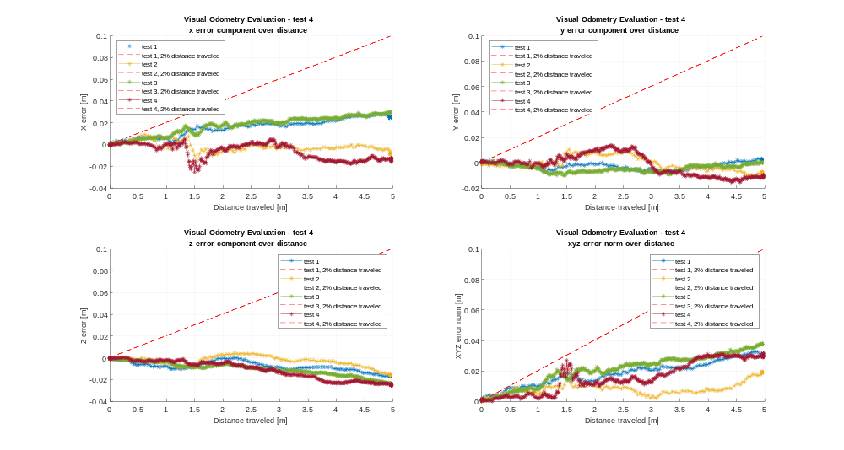

LOW LIGHT SCENARIO:
In a lower light setting (226.2742 lux, while the previous tests were all run with the lab fully lit at 422.2425 lux) at 0.07m/s the SpartanVO in auto-exposure struggles and reducing the exposure-time does not improve performances.
test1: auto-exposure
test2: exposure-time=300ms
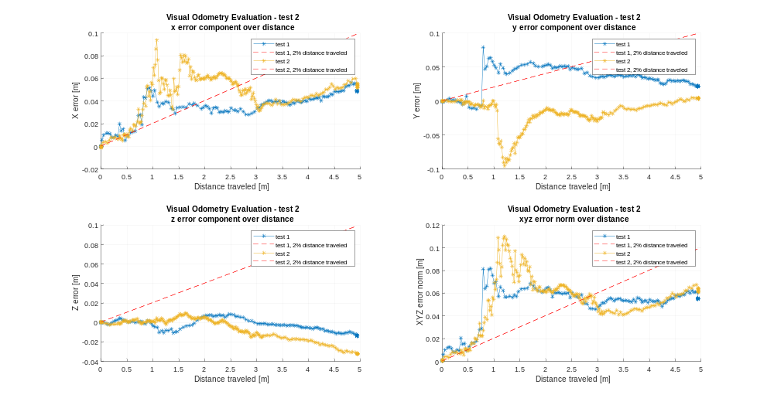
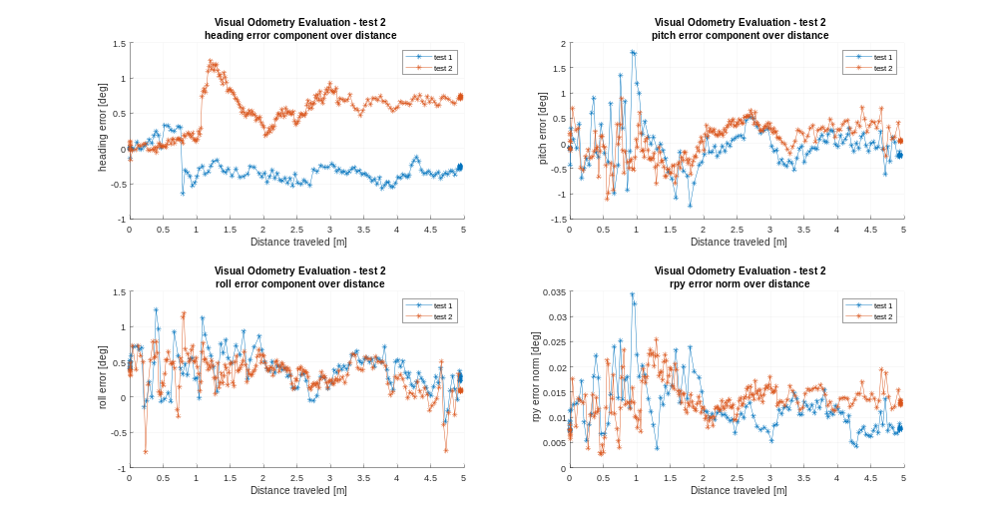

The possibility of increasing the exposure-time, which would have the positive effect of increasing the brightness but also the negative effect of increasing the motion blur, has been investigated.
The test clearly shows that it actually decreases the VO performances.
test1: auto-exposure
test2: exposure-time=600ms
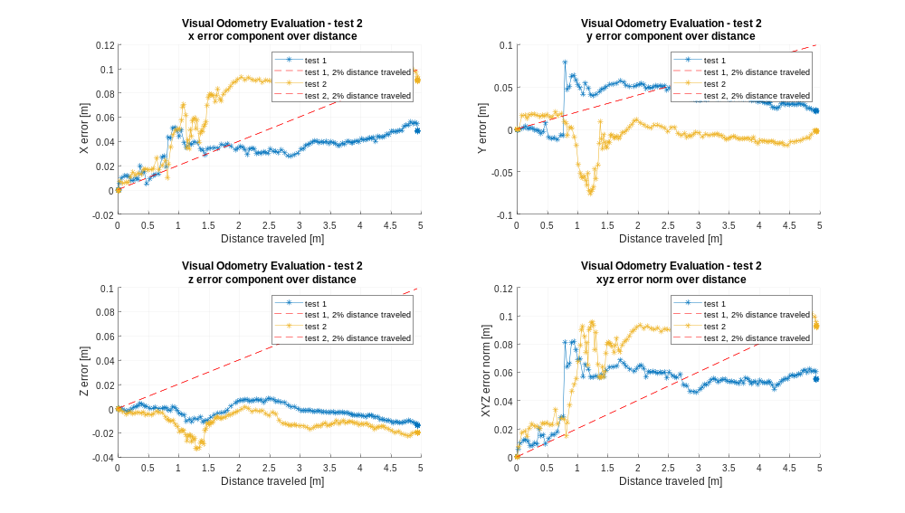
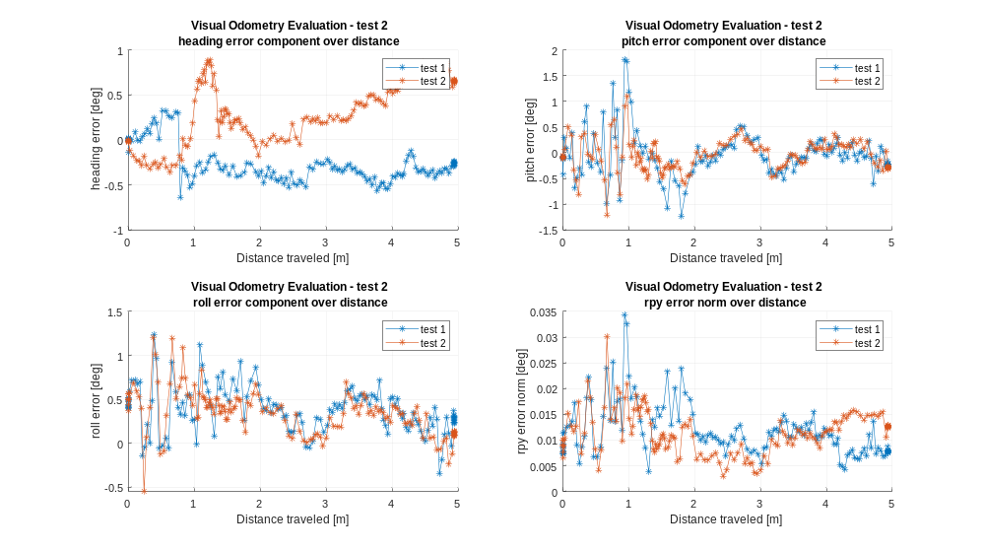
Also a low light and slow speed (0.02m/s) scenario has been tested.
It is clear that increasing and decreasing the exposure time is not beneficial.
test1: auto-exposure (around 500)
test2: exposure-time=600ms
test2: exposure-time=300ms
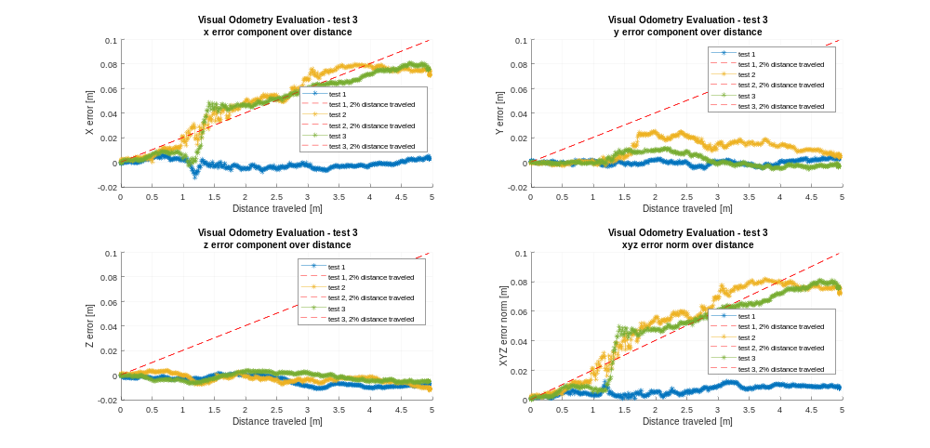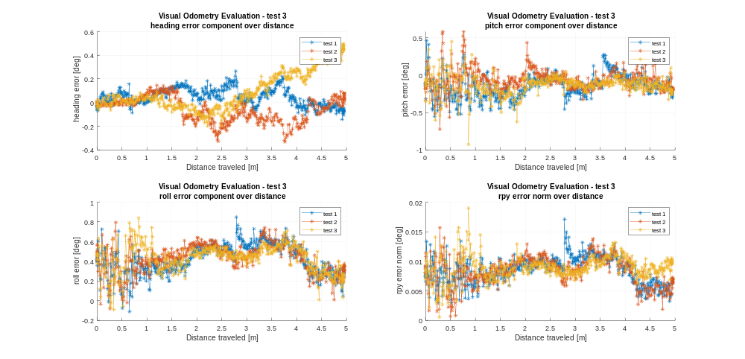
These tests in a low light setting show that low speed alone is able to obtain better performances (xyz error norm of about 1mm) than a high speed traverse also changing the exposure time (xyz error norm of at least 6mm).

The low light scenario has been obtained by just switching off some of the lights in the lab and closing all the curtains of the windows in order to avoid external disturbances and be able to replicate the same conditions in the future.
The ambient light has then been measured using a digital light meter (Flashmate L-308s) aimed at the ground of the Mars Test Bed from the same point of view of the rover’s camera and set in reflected-light mode (lumisphere away from the meter cell, ISO set to 100 and EV output) to better capture the amount of light that the camera is actually exposed to (which will then affect the image and the camera’s auto-exposure calculation).
The sensor reading is in EV (Exposure Value) which can be easily transformed in lux with a logarithmic transformation: lux=2.5*2^EV.

FUTURE OBJECTIVES:
The next parameter that could be investigated is the VO frequency.
I started looking into ways of forcing the VO to run at a specific frequency, and since the rover does not run a real time OS, the most promising option is to change the camera fps, trying to stay above the WCET (Worst Case Execution Time) of a SpartanVO step in order to avoid missing frames and therefore having gaps of twice the camera period in the VO estimates.

